Charlie's Chocolate Factory company produces chocolates. The following product information is stored: product name, product ID, and quantity on hand. These chocolates are made up of many components. Each component can be supplied by one or more suppliers. The following component information is kept: component ID, name, description, quantity on hand, suppliers who supply them, when and how much they supplied, and products in which they are used. On the other hand following supplier information is stored: supplier ID, name, and activation status.

**Assumptions**

* A supplier can exist without providing components.
* A component does not have to be associated with a supplier. It may already have been in the inventory.
* A component does not have to be associated with a product. Not all components are used in products.
* A product cannot exist without components.

**Create an ERD to show how you would track this information. (You can use draw.io)**

* Show entity names, primary keys, attributes for each entity, and relationship types between the entities.

Mevcut durumda 3 tablomuz var. Bunlar:

**Product :** Prod_id(PK), Prod_name, QuantonHand

**Component:** Comp_id(PK), Name, Description, QuantonHand, Supp_id(PK), Supp_date, Supp_method, Prod_id(PK)

**Supplier:** Supp_id(PK), Name, Active_Status

Bu tablolardan verilenlere göre Component ile Product ve Component ve Supplier arasında bir bağlantı olmamalı. Ayrıca Component tablosuna bakınca bunun içinde birden çok PK ların olduğunu görüyoruz. Yani burada da many to many bir ilişki var. Bundan dolayı Component tablosunu bölmemiz gerekir. Buradan **Component Supplier** ile **Use Product** isimli iki tablo daha oluşturuyoruz.

Assumptiona göre A Supp_id component sağlamasada vardır. Yani cardinality S-C arasında 1-0 dır.

Yine assumptiona göre Prod_id component olmadan olamayacağından mandatory ilişki P-C arasında 1-1 dir.

Bunlara göre yeni tablolarımız:

**Product :** Prod_id(PK), Prod_name, QuantonHand

**Supplier:** Supp_id(PK), Name, Active_Status

**Component:** Comp_id(PK), Name, Description

**CompSupp** = Comp_id(PK, FK1), Supp_id(PK, FK2), Supp_date, Supp_Method

**UseProd** = Comp_id(PK, FK1), Prod_id(PK, FK2), QuantofComp

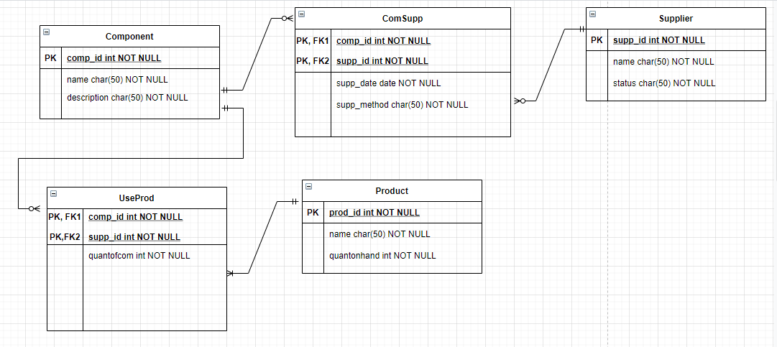

**Do the following exercises, using the data model you designed before.**

     a) Create a database named "Manufacturer"

     b) Create the tables in the database.

     c) Define table constraints.

CREATE DATABASE Manufacturer

CREATE TABLE Component(

[Comp_ID] [int] NOT NULL,

[Comp_Name] [nvarchar](50) Not NULL,

[Comp_Description] [nvarchar](50) Not NULL

);

CREATE TABLE Product(

[Prod_ID] [int] NOT NULL,

[Prod_Name] [nvarchar](50) Not NULL,

[QuantonHand] [int] Not NULL

);

CREATE TABLE Supplier(

[Supp_ID] [int] NOT NULL,

[Supp_Name] [nvarchar](50) Not NULL,

[Supp_Status] [nvarchar](50) Not NULL

);

CREATE TABLE UseProd (

[Prod_ID] [int] PRIMARY KEY NOT NULL,

[Comp_ID] [int] NOT NULL,

[Quant_Of_Com] [int] NOT NULL,

);

CREATE TABLE ComSupp (

[Comp_ID] [int] PRIMARY KEY NOT NULL,

[Sup_ID] [int] NOT NUL

[Sup_Date] DATE NOT NULL,

[Sup_Status] [nvarchar](50) NOT NULL

);